The Dream Team

Professor Greg Blonder

Product Design

19th October, 2020

Mask Dispensing Machine Critical Uncertainty Demo

**Product Description and Critical Uncertainty**

The goal of a mask dispensing machine is to provide masks in a sterile, efficient and clean manner. This need was brought about by the changing awareness of public health because of the ongoing pandemic. The idea is to use two sets of wheels to dispense plastic-covered masks (stacked vertically) one at a time. In our design process, we have classified the dispensing of one mask as the critical uncertainty because of how it may be difficult to dispense only one mask due to the nature of these thinly designed masks. We chose this critical uncertainty for a few reasons. In the age of the coronavirus and even in general, it is important to be as conservative with as much material as possible- we do not want to waste important resources. People may be less inclined to use the extra dispensed mask because it may have fallen into someone else’s hands by accident. Because of this, it is critical to the product that only one mask is dispensed.

**Experiments Done & Analysis**

After the establishment of our critical uncertainty, we focused heavily on developing our dispensing mechanism for this demo and we needed to test various methods to verify which would be the most effective. We had two different methods in mind; both utilized a set of larger wheels for the primary dispensing force, and a second set of smaller wheels for alignment purposes and to ensure only one mask was output at a time. The main difference between these two methods is one would be gravity-fed, with masks being fed off of the bottom of the stack, and the other would be spring-loaded, dispensing one mask off of the top of the stack.

After coming up with our two ideas to test, we also delved deeper into the critical uncertainty definition and further realized what our limiting factors in this design would be. Our first limiting factor would be the coefficient of friction between the wheels and the plastic wrapping of the masks. One design component related to this limiting factor was the wheel surface. We came up with a few ideas for different wheel surfaces, which included the regular tread rubber of the K'nex wheels, rubber bands used along the outer diameter of the wheels, a single bead of dried hot glue along the outer surface, and a zig-zag bead of dried hot glue along the surface. Another design component related to this factor was the height of the wheel protrusion from the bottom or top of the device. This ultimately dictates the arc length of the wheel that’s in contact with the dispensed mask at any given point. To incorporate this into our testing and adjust our expeiments, we created a slot in which the large wheel axle can sit, allowing us to change the height at which the wheels sit within the device. 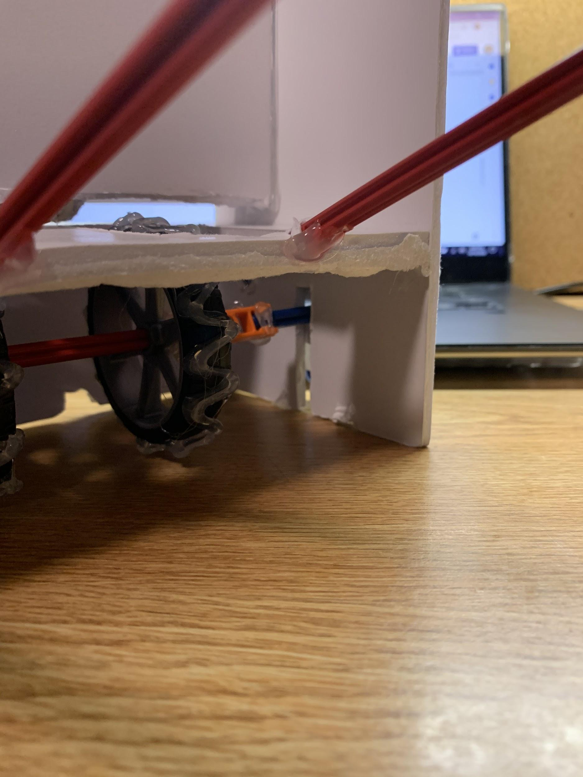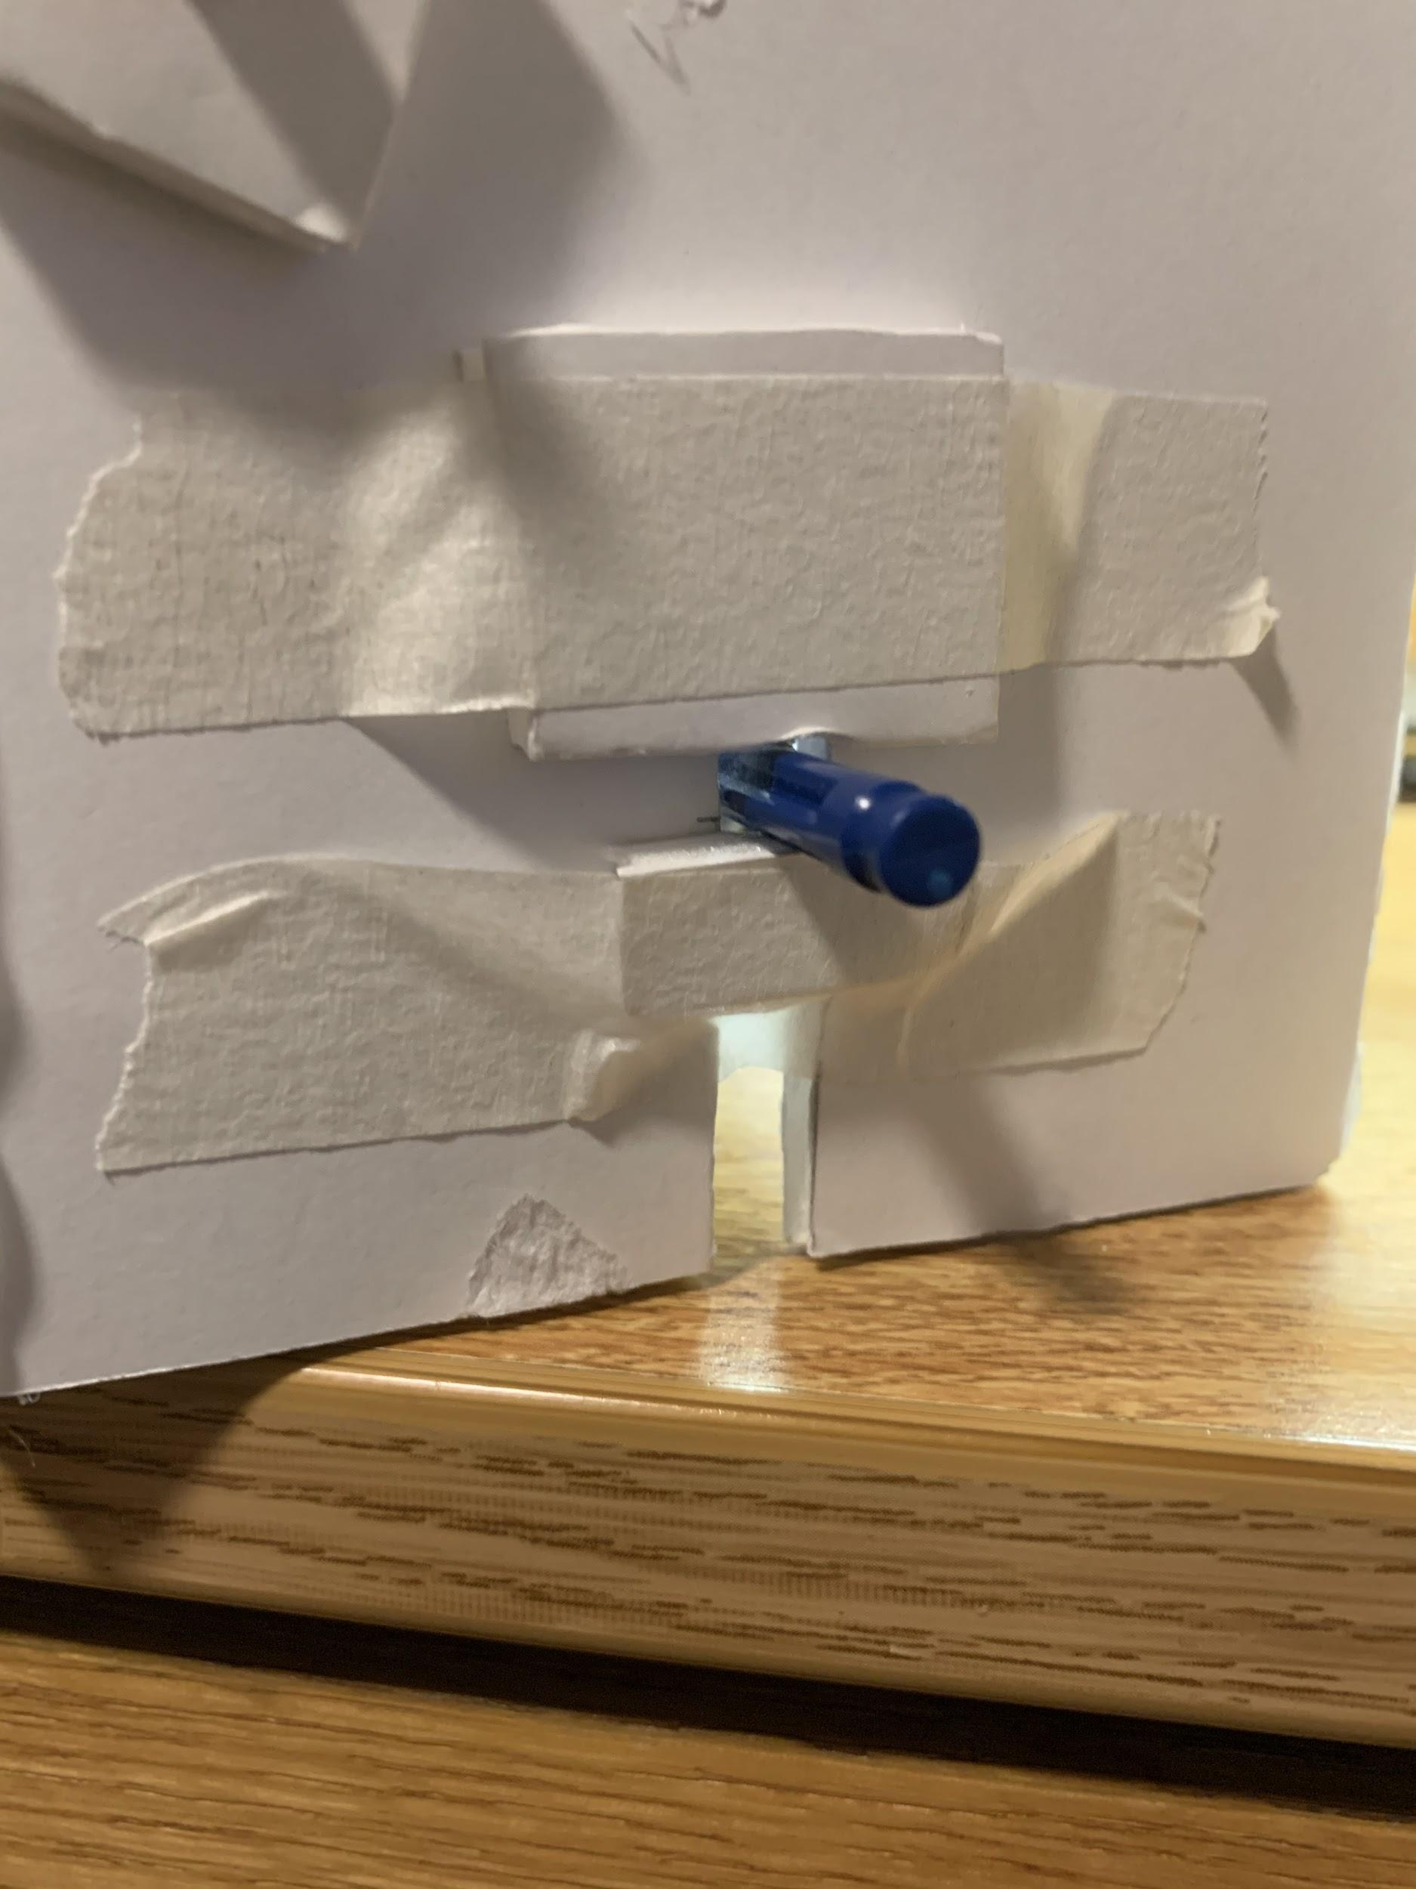

Our second limiting factor was slightly related to the first, but it deals mostly with the ability of the wheels to feed the mask downwards and underneath the dividing wall in front of the smaller wheels. This factor was controlled by two constraints: both the forward position of the larger wheels and the height of the dividing wall. We did not implement a way to test the forward position of the wheels, but we did observe the effect of having the wheel too far forward. When the position was overestimated, the mask was directed upwards into the wall, creating clearance issues and causing the mask to not be dispensed at all. To account for the effect of dividing wall height, we started with an extremely small clearance and slowly trimmed material off the bottom, increasing the clearance until the device functioned properly.

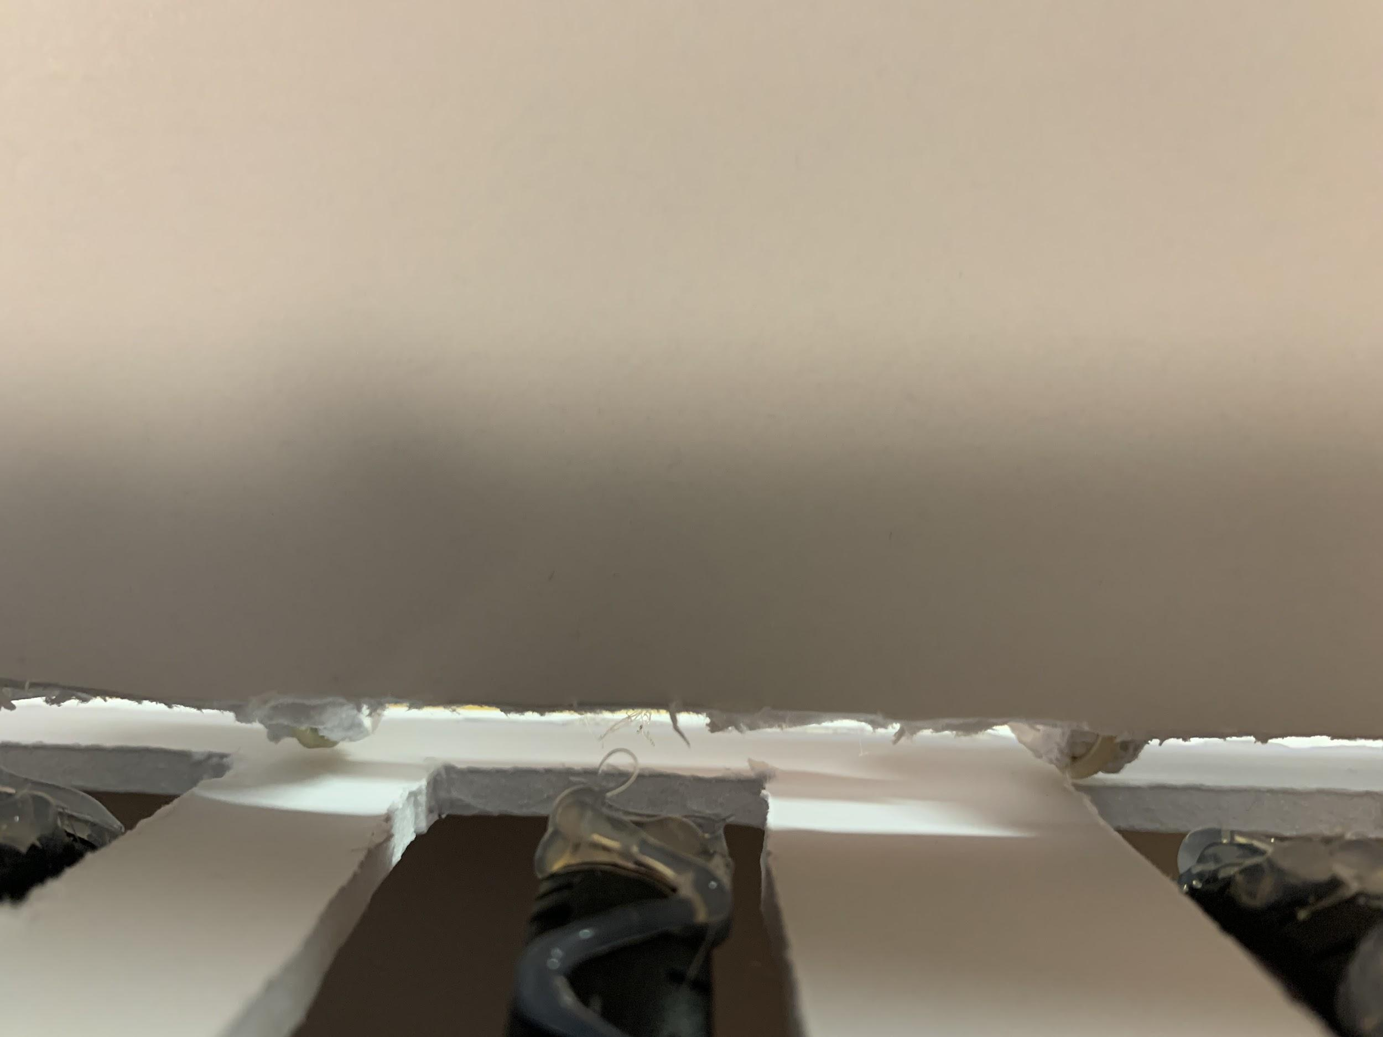

For our first test, we opted to try top loading. With this scenario, we created a platform which would raise the masks and apply upward force for the masks to gain friction with the larger wheels at the top. In a final setup, this action would be done by springs, but for our testing purposes, we simply used strings and added tension upwards to create friction between the wheels and the masks. Ultimately, this method was concluded as inferior to the bottom dispensing method, due to the increased complexity of the top loading design, and the upward pressure needed to create the friction with the wheels.

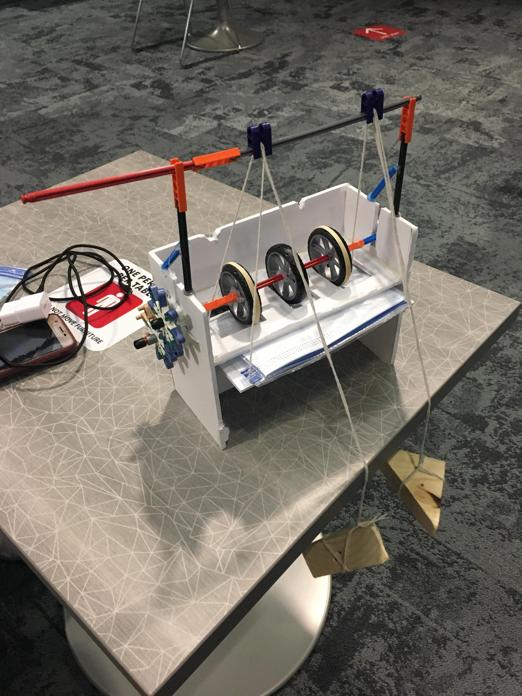

Upon experimentation with the bottom loading design, it was concluded that zig zag hot melt glue beads were optimal for the bottom wheels and rubber bands with a rib/flange cut were optimal for the top treads. This made us realize that our optimal wheel would have a ‘sticky’ rubber with as wide of a tread area as possible. The rib/flange is also an important characteristic we will look for when purchasing our wheels. Any constraint that allows us more surface area contacting the mask was ideal and three wheels rather than two would allow for this, despite being a more expensive option. The argument here is that in case that the two outer wheels don’t get a good enough hold onto the ends of the mask or if the mask comes down at an angle, the middle wheel can help grab onto the mask and provide a grip that will be necessary to push it out. As for the vertical clearance of the bottom wheels, we concluded that a distance within the range of 0.375” to 0.5” was optimal. The top wheels should have as little clearance as possible to allow a mask to fit width wise, even if it is compressed between the wheels.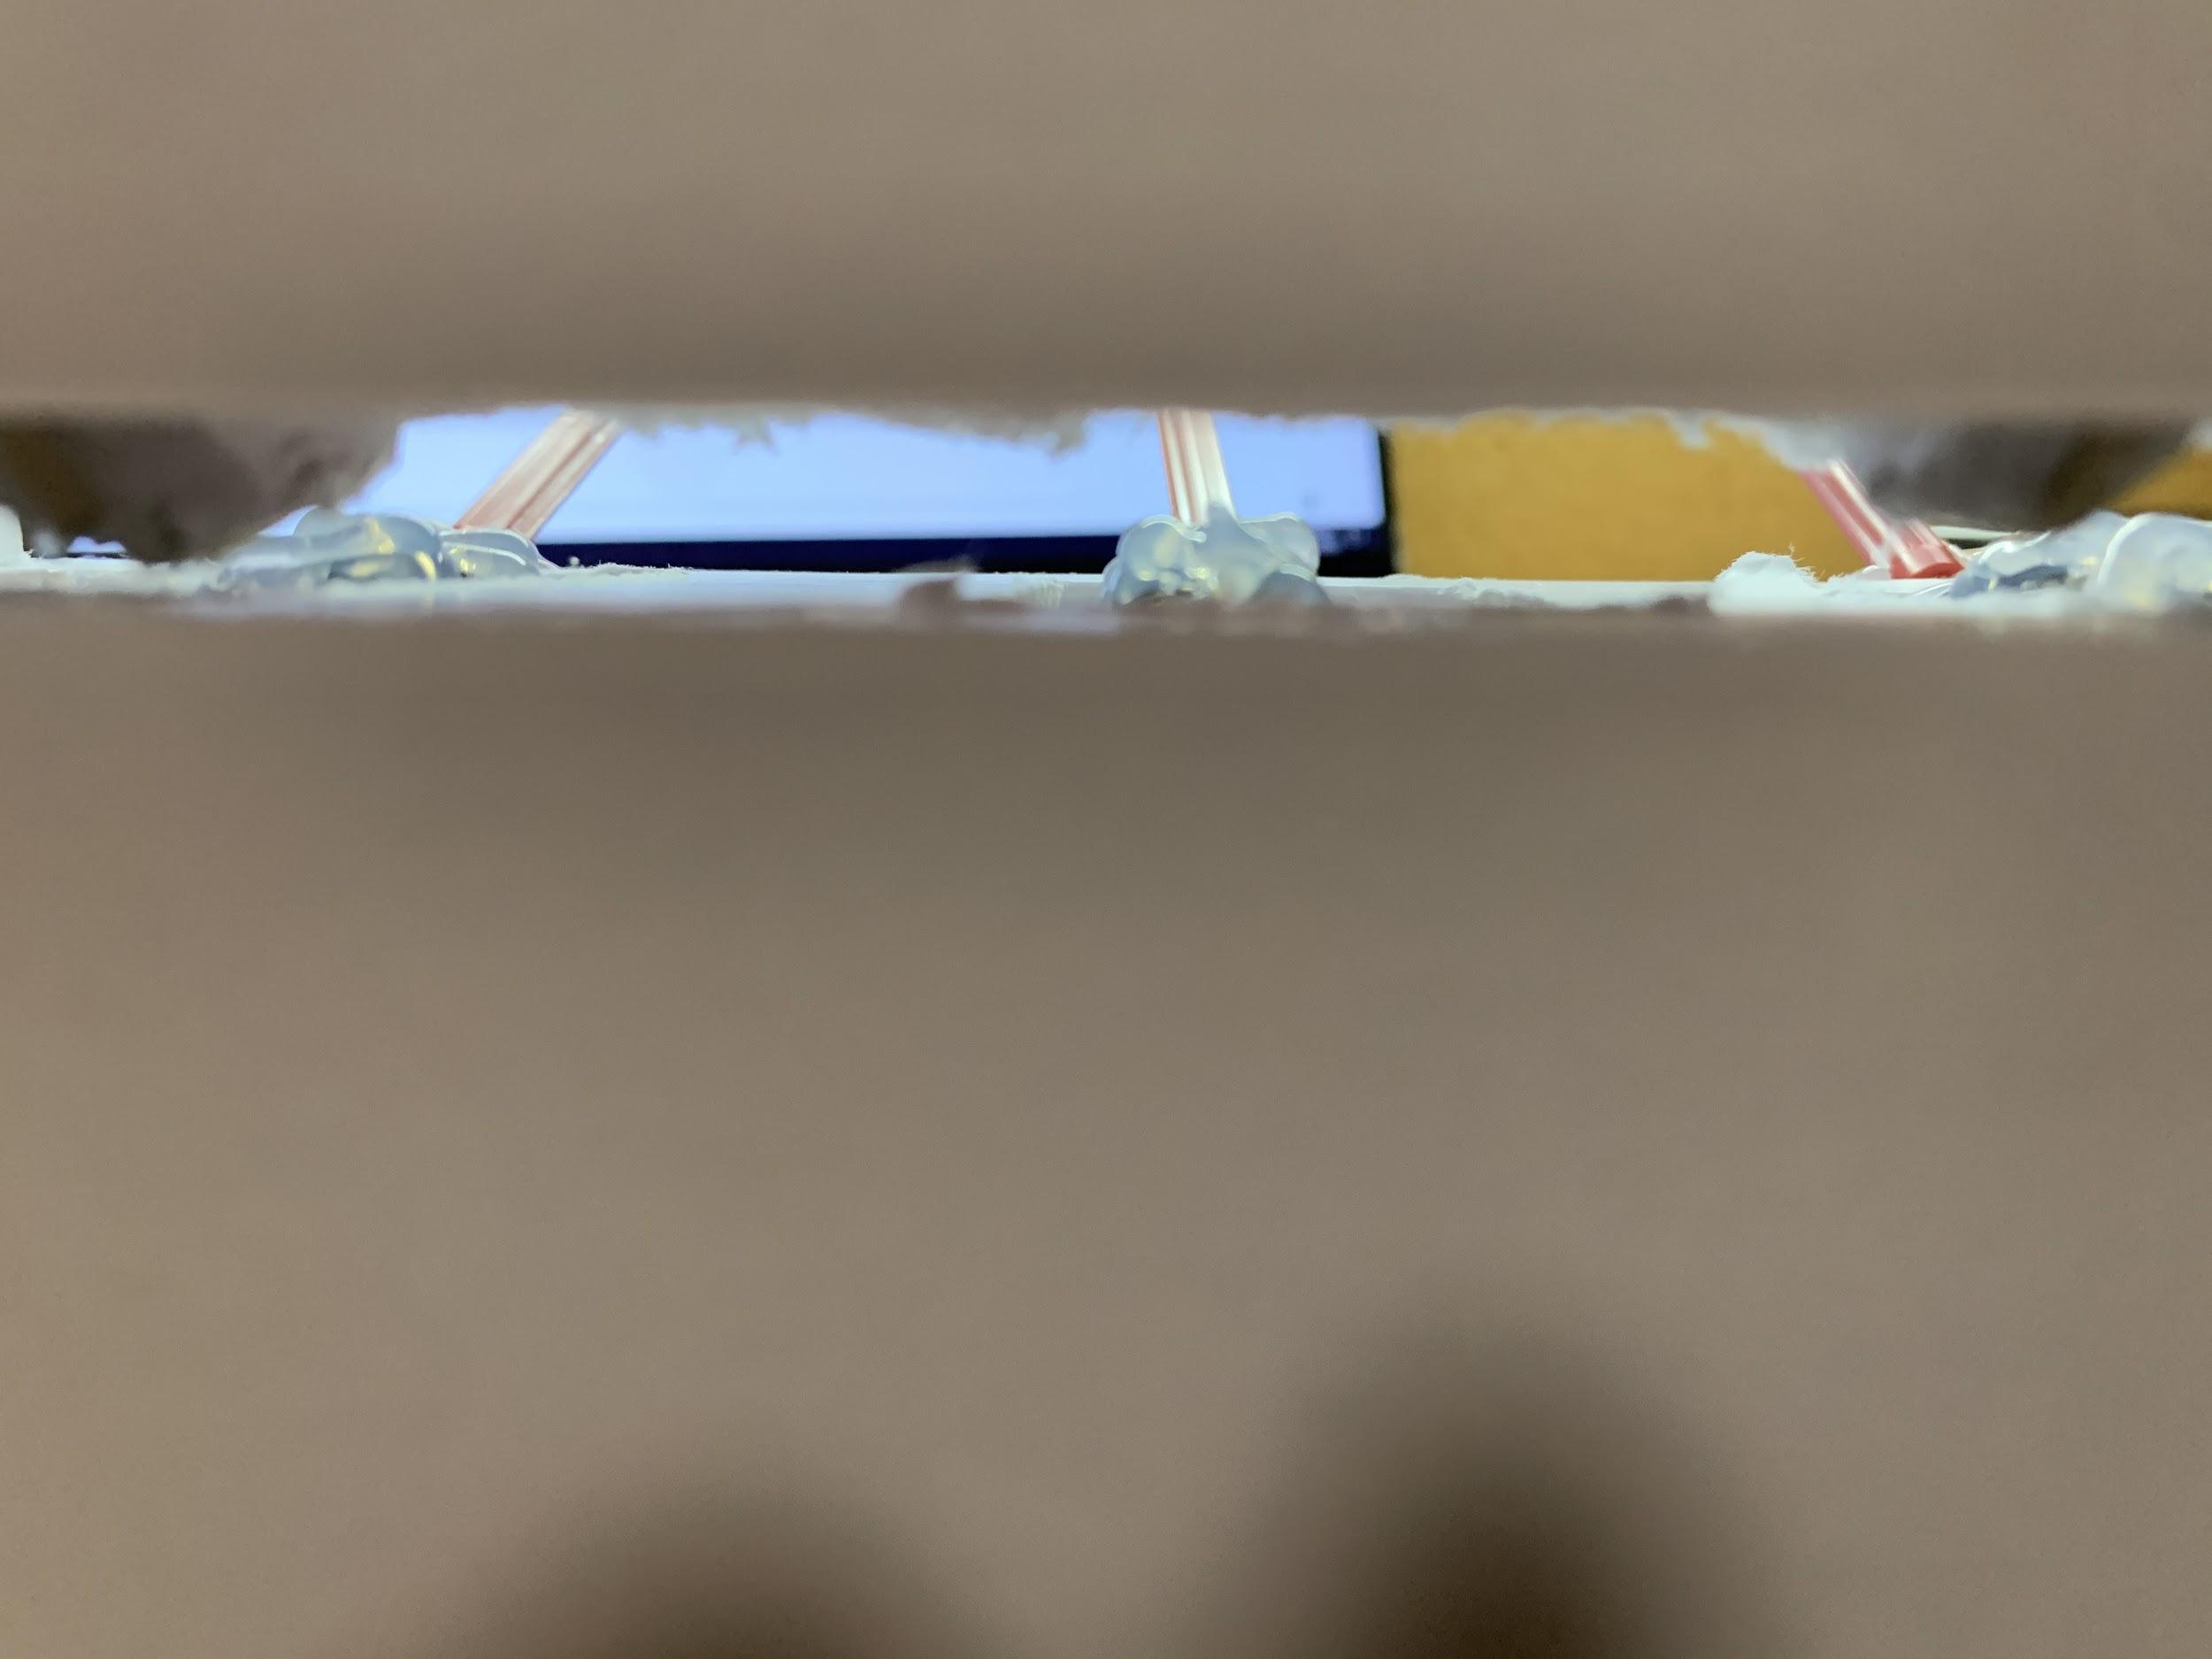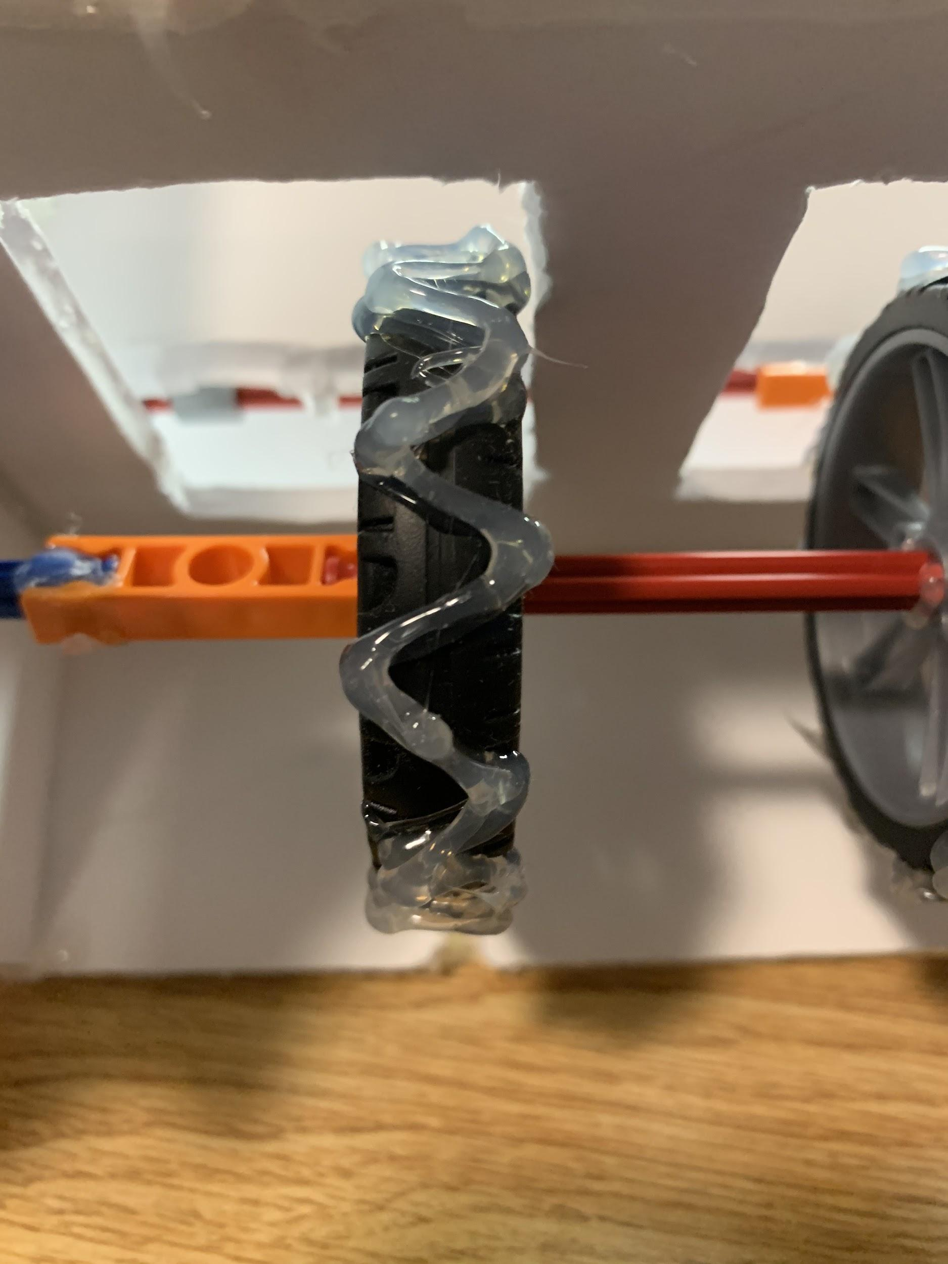

As for the front to back spacing of the bottom wheels, we concluded that the highest point of the bottom wheel should be behind the midpoint of the masks. To make sure we have enough clearance underneath the dividing wall, we found that a wall clearance of around 0.5” was optimal. This will ensure that only one mask is dispensed while still giving room for the mask to properly clear the wall.

**Video Demos**

**Top Loading :** <https://youtu.be/PIkdDx1driM>

**Bottom Loading:** <https://youtu.be/yID9rMVgwgk>